**MONGODB 9th June**

**IN JAVA ECLIPSE CREATING DATABASE**

package connection;

import org.bson.Document;

import com.mongodb.client.MongoClient;

import com.mongodb.client.MongoClients;

import com.mongodb.client.MongoCollection;

import com.mongodb.client.MongoDatabase;

import com.mongodb.client.MongoIterable;

public class MongoDBConnection {

public static void main(String[] args) {

// Creating a Mongo client

MongoClient mongoClient = MongoClients.*create*("mongodb://localhost:27017");

MongoDatabase database = mongoClient.getDatabase("monday127");

database.createCollection("employeeRecord");

// Retrieving a collection

MongoCollection<Document> collection = database.getCollection("sampleCollection");

Document document = new Document("title", "MongoDB");

//Inserting document into the collection

collection.insertOne(document);

MongoIterable<String> loop1 = mongoClient.listDatabaseNames();

for (String name : loop1) {

System.*out*.println(name);

}

}

}

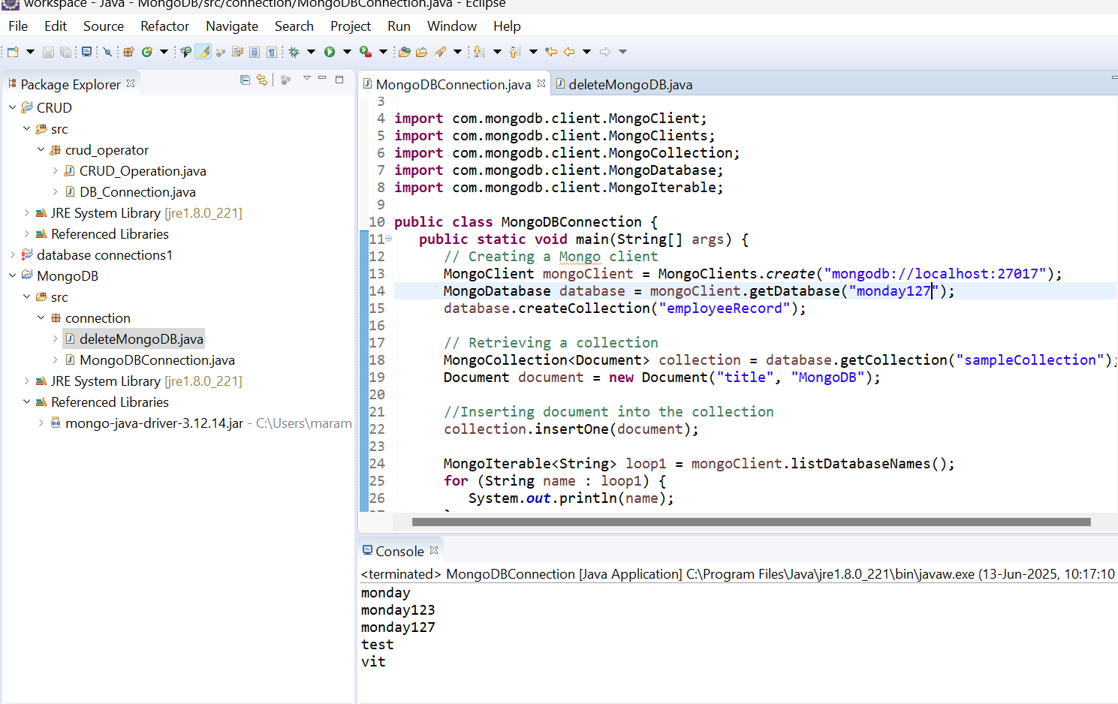

**IN JAVA ECLIPSE DELETING DATABASE**

**package** connection;

**import** com.mongodb.client.MongoClient;

**import** com.mongodb.client.MongoClients;

**import** com.mongodb.client.MongoDatabase;

**import** com.mongodb.client.MongoIterable;

**public** **class** deleteMongoDB {

**public** **static** **void** main(String[] args) {

MongoClient mongoClient = MongoClients.*create*("mongodb://localhost:27017");

MongoDatabase database = mongoClient.getDatabase("monday127");

database.drop();

System.***out***.println("Database dropped");

MongoIterable<String> loop1 = mongoClient.listDatabaseNames();

**for** (String name : loop1) {

System.***out***.println(name);

}

}

}

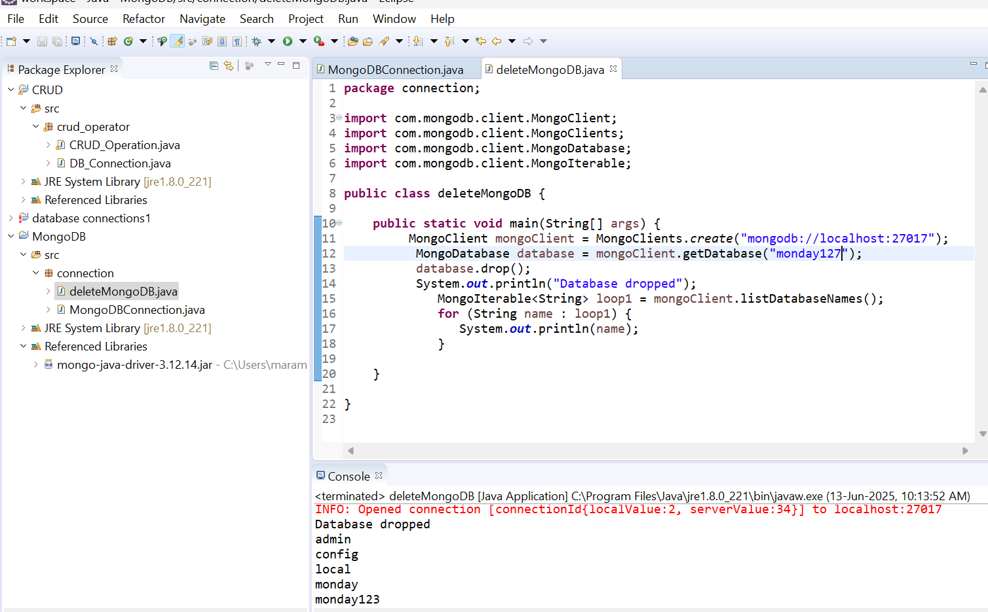

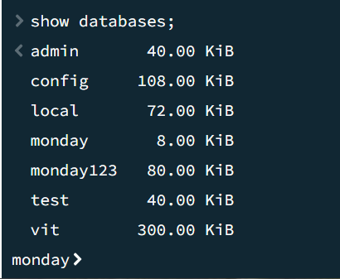

**CREATE COLLECTION**

**package** connection;

**import** org.bson.Document;

**import** com.mongodb.client.MongoClient;

**import** com.mongodb.client.MongoClients;

**import** com.mongodb.client.MongoCollection;

**import** com.mongodb.client.MongoDatabase;

**import** com.mongodb.client.MongoIterable;

**public** **class** CreateCollection {

**public** **static** **void** main(String[] args) {

// Creating a Mongo client

MongoClient mongoClient = MongoClients.*create*("mongodb://localhost:27017");

MongoDatabase database = mongoClient.getDatabase("monday127");

database.createCollection("sampleCollection");

System.***out***.println("Created Collection");

}

}

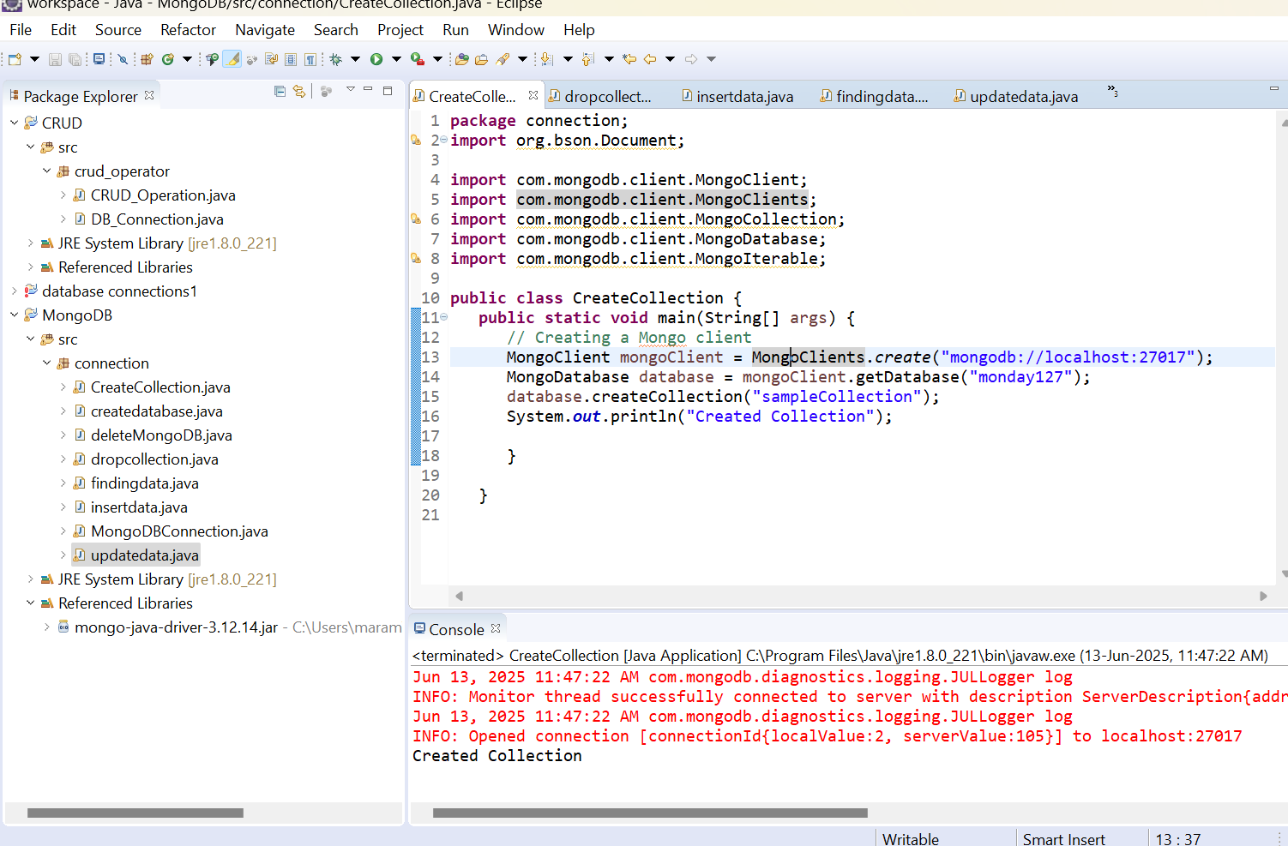

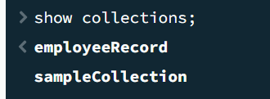

**DROP COLLECTION**

**package** connection;

**import** org.bson.Document;

**import** com.mongodb.client.MongoClient;

**import** com.mongodb.client.MongoClients;

**import** com.mongodb.client.MongoCollection;

**import** com.mongodb.client.MongoDatabase;

**import** com.mongodb.client.MongoIterable;

**public** **class** dropcollection {

**public** **static** **void** main(String[] args) {

// Creating a Mongo client

MongoClient mongoClient = MongoClients.*create*("mongodb://localhost:27017");

MongoDatabase database = mongoClient.getDatabase("monday127");

database.createCollection("sampleCollection");

// Retrieving a collection

MongoIterable<String> collections = database.listCollectionNames();

MongoCollection<Document> collection = database.getCollection("sampleCollection");

collection.drop();

System.***out***.println("Collection droped and remaining");

**for**(String name:collections){

System.***out***.println(name);

}

}

}

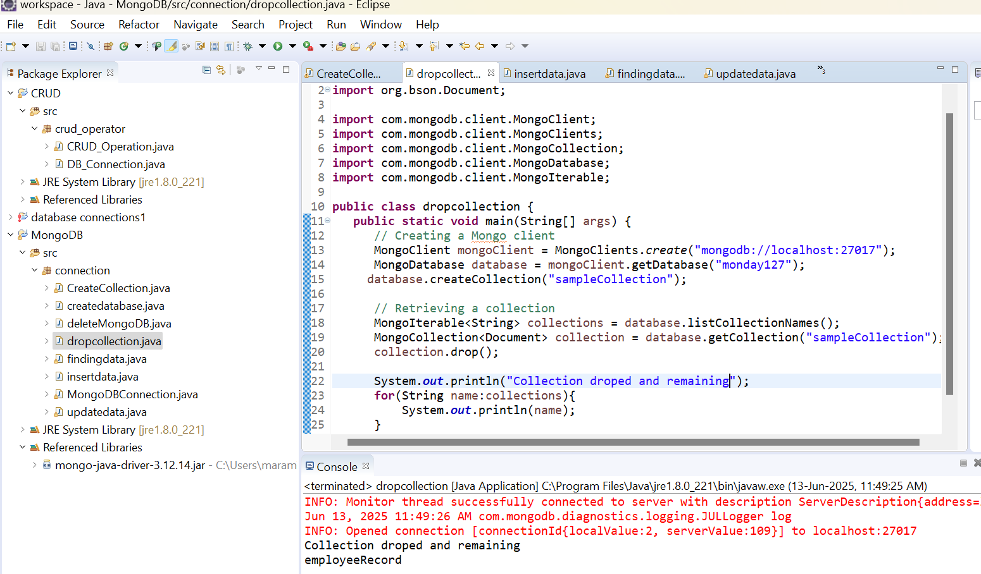

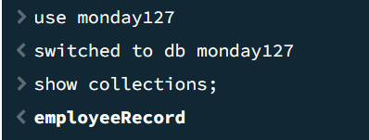

**DATA INSERTEDIN COLLECTION**

**package** connection;

**import** java.util.ArrayList;

**import** java.util.List;

**import** org.bson.Document;

**import** com.mongodb.client.MongoClient;

**import** com.mongodb.client.MongoClients;

**import** com.mongodb.client.MongoCollection;

**import** com.mongodb.client.MongoDatabase;

**public** **class** insertdata{

**public** **static** **void** main(String[] args) {

MongoClient mongoClient = MongoClients.*create*("mongodb://localhost:27017");

MongoDatabase database = mongoClient.getDatabase("monday127");

// Get the collection

MongoCollection<Document> collection = database.getCollection("sampleCollection");

Document document = **new** Document("First_Name", "Mahesh")

.append("Last_Name", "Parashar")

.append("Date_Of_Birth", "1990-08-21")

.append("e_mail", "mahesh_parashar.123@gmail.com")

.append("phone", "9034343345");

collection.insertOne(document);

List<Document> documents = **new** ArrayList<>();

documents.add(**new** Document("First_Name", "Radhika")

.append("Last_Name", "Sharma")

.append("Date_Of_Birth", "1995-09-26")

.append("e_mail", "radhika_sharma.123@gmail.com")

.append("phone", "9000012345"));

documents.add(**new** Document("First_Name", "Rachel")

.append("Last_Name", "Christopher")

.append("Date_Of_Birth", "1990-02-16")

.append("e_mail", "Rachel_Christopher.123@gmail.com")

.append("phone", "9000054321"));

documents.add(**new** Document("First_Name", "Fathima")

.append("Last_Name", "Sheik")

.append("Date_Of_Birth", "1990-02-16")

.append("e_mail", "Fathima_Sheik.123@gmail.com")

.append("phone", "9000054321"));

collection.insertMany(documents);

System.***out***.println("Documents inserted.");

}

}

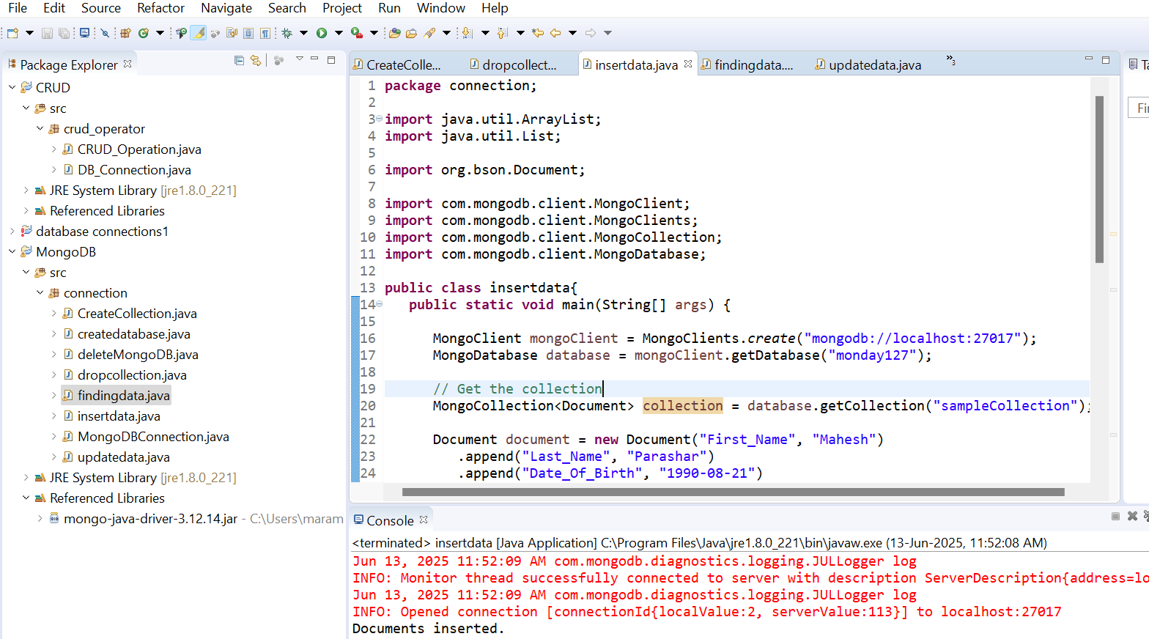

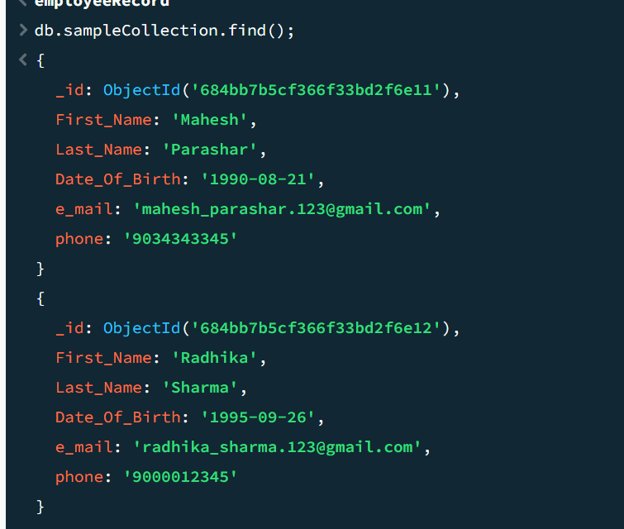

**FINDING DATA**

**package** connection;

**import** java.util.Scanner;

**import** java.util.ArrayList;

**import** java.util.List;

**import** org.bson.Document;

**import** com.mongodb.client.FindIterable;

**import** com.mongodb.client.MongoClient;

**import** com.mongodb.client.MongoClients;

**import** com.mongodb.client.MongoCollection;

**import** com.mongodb.client.MongoDatabase;

**import** com.mongodb.client.model.Filters;

**public** **class** findingdata{

**public** **static** **void** main(String[] args) {

Scanner sc=**new** Scanner(System.***in***);

MongoClient mongoClient = MongoClients.*create*("mongodb://localhost:27017");

MongoDatabase database = mongoClient.getDatabase("monday127");

// Get the collection

MongoCollection<Document> collection = database.getCollection("sampleCollection");

// FindIterable<Document> allDocuments= collection.find();

// for(Document document: allDocuments){

// System.out.println(document);

//}

System.***out***.println("enter which colomn data you have");

String a=sc.nextLine();

System.***out***.println("enter the value to search");

String b=sc.nextLine();

FindIterable<Document> documents=collection.find(Filters.*eq*(a,b));

**for**(Document document:documents){

System.***out***.println(document);

}

}}

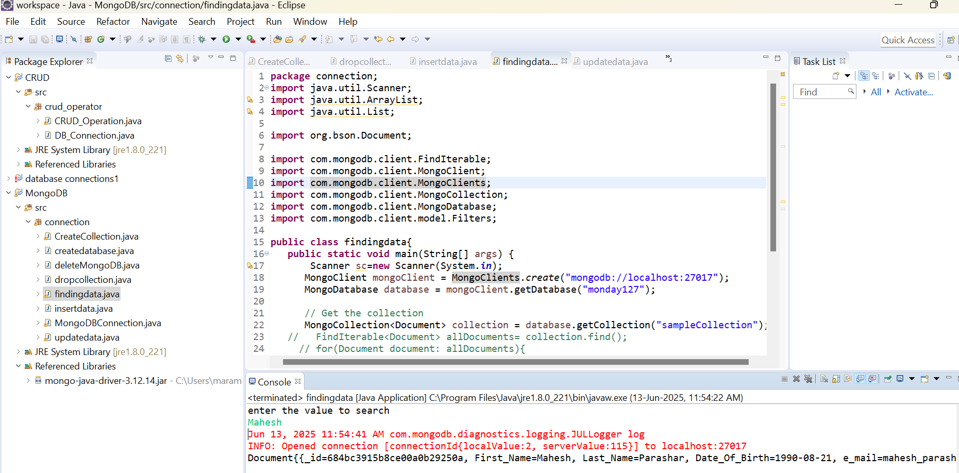

**UPDATE DATA**

**package** connection;

**import** java.util.Scanner;

**import** org.bson.Document;

**import** com.mongodb.client.FindIterable;

**import** com.mongodb.client.MongoClient;

**import** com.mongodb.client.MongoClients;

**import** com.mongodb.client.MongoCollection;

**import** com.mongodb.client.MongoDatabase;

**import** com.mongodb.client.model.Filters;

**import** com.mongodb.client.model.Updates;

**public** **class** updatedata{

**public** **static** **void** main(String[] args) {

Scanner sc=**new** Scanner(System.***in***);

MongoClient mongoClient = MongoClients.*create*("mongodb://localhost:27017");

MongoDatabase database = mongoClient.getDatabase("monday127");

System.***out***.println("enter which column which you have");

String a=sc.nextLine();

System.***out***.println("enter which row you want to update");

String b=sc.nextLine();

System.***out***.println("enter what to add");

String c=sc.nextLine();

System.***out***.println("enter values to update");

String d=sc.nextLine();

// Get the collection

MongoCollection<Document> collection = database.getCollection("sampleCollection");

collection.updateOne(Filters.*eq*(a,b),

Updates.*set*(c,d));

System.***out***.println("Document updated");

FindIterable<Document> Documents= collection.find(Filters.*eq*(a,b));

**for**(Document document: Documents){

System.***out***.println(document);

}

}}

